## Sprint 4 Meeting Minutes

Date: 28 March, 2024

Time: 10:35 AM

Location: Online

## Attendees

* Mahmoud Mustafa
* Thomas Mahut
* Adam Tahle
* Alex Page
* Vincent Nguyen
* Azal Al-Mashta

## Absentees

## Agenda

* Read the sprint 4 instructions together and take notes.
* Discuss the task breakdown of the extra feature and split the tasks.

## Discussions

* Discussed creating a card, a tagline, and a button for the feature available on the homepage. Potential taglines
  + *Swipe left or right to find the perfect car!*
  + *Find your perfect car!*
* Discussed the importance of following the code review guidelines (Sprint 4 Guidelines, Appendix B) when a member makes a review.
* Discussed the procedure in which the feature will look to the user.
  + User gets presented with the tagline
  + Followed by a brief synopsis to explain the game.
  + Then a button to “try car-matcher”.
* Need to put swipe buttons under the vehicle cards and not in them
* Considered the possibility of storing matched vehicles (and the date they were matched) so that users can go back and see what vehicles they once matched with.
* Considered the possibility of adding a percentage to the final vehicle match, based on how closely this suggested vehicle matches their “vehicle preference profile”.
* Considered the possibility of adding a “Super Match” button that when pressed would directly choose that car as the most probable pick for the user.

## Decisions Made

* Decide to put a picture and vehicle details in the vehicle card.
* Decided that we will forget about swiping for now as it is low priority and potentially difficult to implement, sticking to the thumbs up & thumbs down button for now. Decision was made unanimously.
* After lengthy discussion, we settled on the Daniel approach (see image below), where an image AND as many vehicle details as possible are included in the vehicle card. Decision was made unanimously.
* 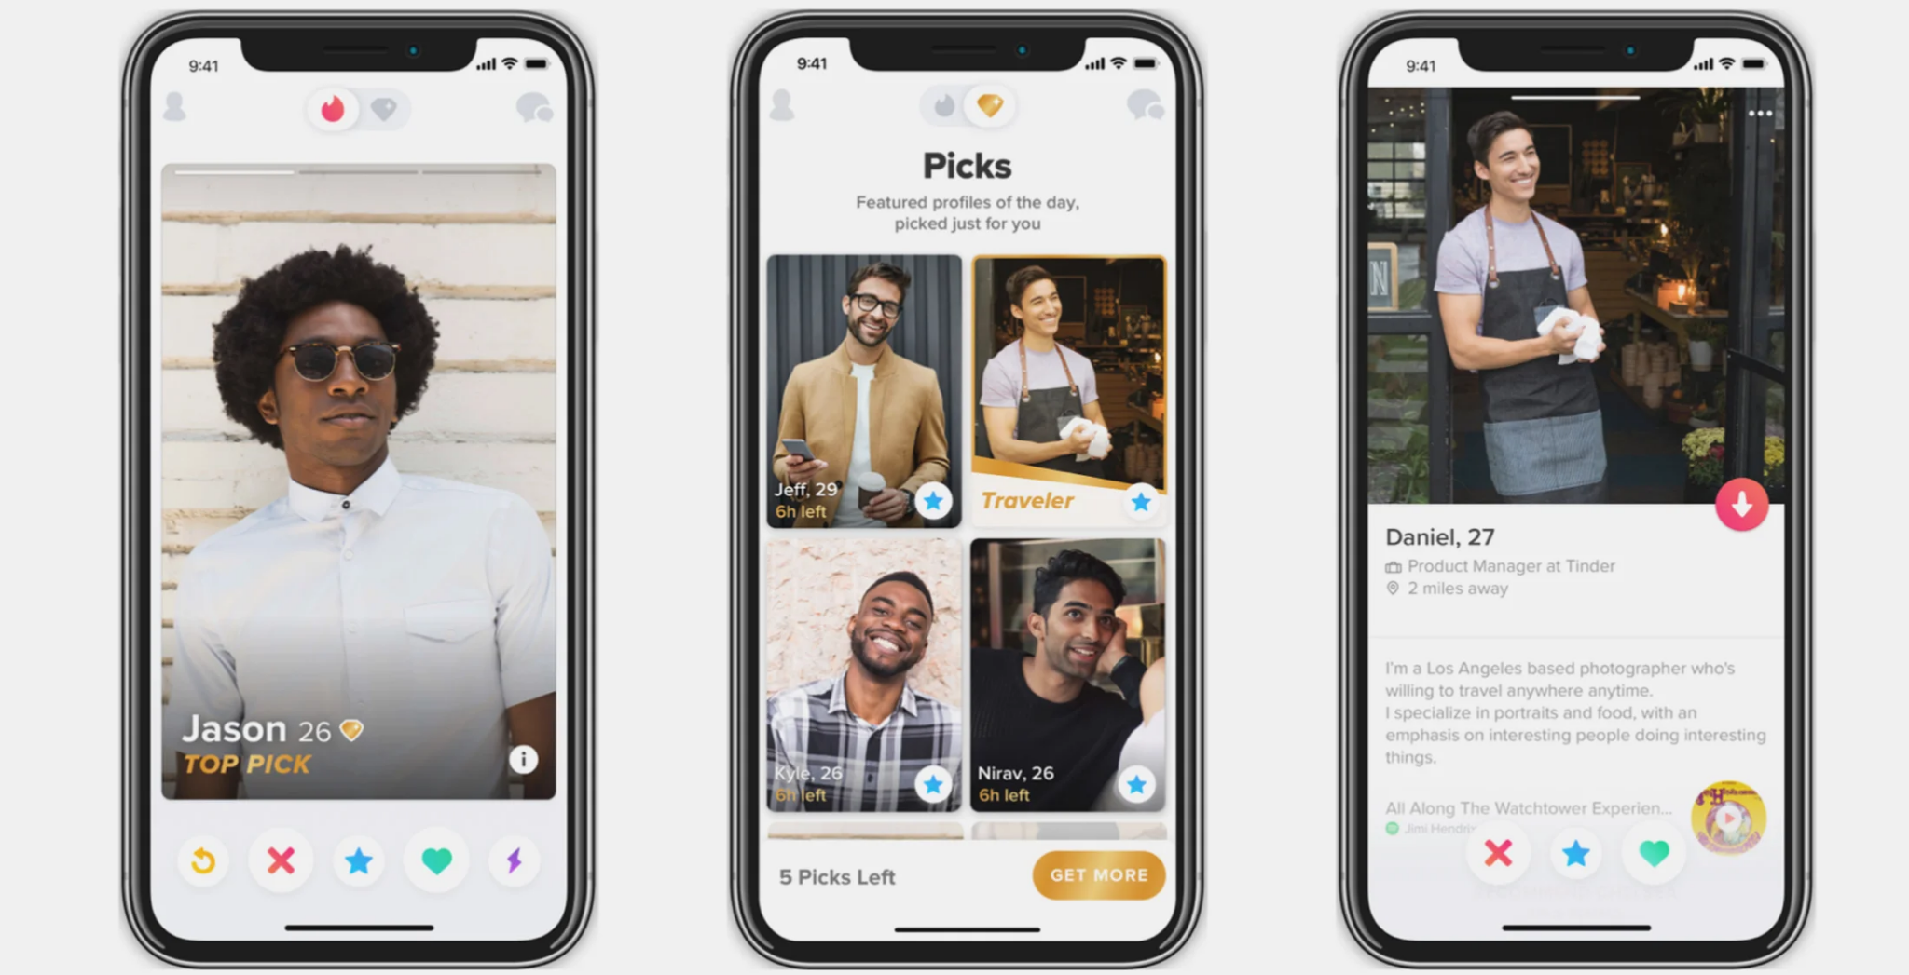
* Split tasks:
  + Initiative on static analysis tool: Thomas
  + 15001: Mahmoud
  + 15002: Adam
  + 15003: Vincent
  + 15004: Adam
  + 15005: Alex
  + 15006: Azal
  + 15007: Mahmoud

## Action Items

* Do assigned tasks before the next meeting.

## Next Meeting

* 2 April, 2024 at 7:30 PM
* Location: Online